
HEALTHCARE COST PREDICTION USING EXPLORATORY DATA ANALYSIS AND REGRESSION
A CAPSTONE PROJECT REPORT
A Capstone Project Report submitted in partial fulfilment of the requirements
for the Course of
DSA0404 – Fundamentals of Data Science
to the award of the degree of
BACHELOR OF ENGINEERING
IN
ARTIFICIAL INTELLIGENCE AND DATA SCIENCE
Submitted by
Y. Anjani Priya (192324176)
Under the Supervision of
Dr. Krishnaraj M
SIMATS ENGINEERING
Saveetha Institute of Medical and Technical Sciences
Chennai-602105
SEPTEMBER 2026

SIMATS ENGINEERING
Saveetha Institute of Medical and Technical Sciences
Chennai-602105
BONAFIDE CERTIFICATE
This is to certify that the Capstone Project entitled “Healthcare cost prediction using Exploratory data analysis and regression” has been carried out by Y. Anjani Priya (192324176) under the supervision of Dr. Krishnaraj M and is submitted in partial fulfilment of the requirements for the current semester of the B.Tech Artificial Intelligence and Data Science program at Saveetha Institute of Medical and Technical Sciences, Chennai.

HEAD OF THE DEPARTMENT  Dr. Sriramya P  Department of CSE,  SIMATS Engineering,  SIMATS, Chennai – 602105. | SUPERVISOR  Dr. Krishnaraj M  Department of CSE,  SIMATS Engineering,  SIMATS, Chennai – 602105.

Submitted for the Capstone Project work Viva-Voce held on 04/09/2026

INTERNAL EXAMINER | EXTERNAL EXAMINER

SIMATS ENGINEERING
Saveetha Institute of Medical and Technical Sciences
Chennai-602105
DECLARATION
We, Sania Herbert, Y. Anjani Priya, and M. Apurva of the Artificial Intelligence and Data Science, SIMATS Engineering, Saveetha Institute of Medical and Technical Sciences, Chennai, hereby declare that the Capstone Project Work entitled “Healthcare cost prediction using Exploratory data analysis and regression” is the result of our own bonafide efforts. To the best of our knowledge, the work presented herein is original, accurate, and has been carried out in accordance with the principles of engineering ethics.

Place: Chennai
Date: 04.09.2026

Signature of the Students with Names

SIMATS ENGINEERING
Saveetha Institute of Medical and Technical Sciences
Chennai-602105
Individual Contribution Statement
(Mandatory for all team projects)
Student Name / Register No. | Specific Responsibilities | Design & Development Contribution | Testing & Analysis Contribution | Report Contribution | Approx. Contribution (%)
Y. Anjani Priya  192324176 | To be completed by the team | To be completed by the team | To be completed by the team | To be completed by the team | __%
Total |  |  |  |  | 100%

ABSTRACT
Healthcare expenditure is influenced by a combination of demographic, lifestyle, and regional factors, making cost estimation difficult when decisions rely only on historical averages or manual judgement. This capstone project develops a Healthcare Cost Prediction and Analytics System that uses an insurance dataset containing age, sex, body mass index (BMI), number of children, smoking status, region, and healthcare charges. The project addresses the problem of estimating an individual's expected healthcare cost from a small set of measurable characteristics. The solution follows a three-module architecture. Module 1 performs data cleaning, descriptive analysis, and interactive exploratory visualization. Module 2 trains a multiple linear regression model and provides a local web interface through Streamlit where users can enter patient characteristics and receive a predicted cost. Module 3 evaluates the model using R², mean absolute error (MAE), mean squared error (MSE), root mean squared error (RMSE), residual analysis, and regression coefficients. The original dataset contains 1,338 records and seven variables. One duplicate record was identified and removed, resulting in 1,337 records with no missing values. Using an 80:20 train-test split and a fixed random state of 42, the linear regression model achieved an R² of approximately 0.807, MAE of approximately $4,177, and RMSE of approximately $5,956 on the test set. The resulting application demonstrates how data analytics and machine learning can be converted into an accessible decision-support tool. The system is intended for educational and analytical use rather than clinical diagnosis, insurance underwriting, or medical decision-making.
Keywords
Healthcare cost prediction; Exploratory Data Analysis; Multiple Linear Regression; Streamlit; Machine Learning; Insurance Dataset

TABLE OF CONTENTS
SL.NO | TITLE | PAGE NO
1. | CERTIFICATE FROM THE SUPERVISOR | 1
2. | DECLARATION BY THE CANDIDATE | 2
3. | INDIVIDUAL CONTRIBUTION STATEMENT | 3
4. | ABSTRACT | 4
5. | LIST OF FIGURES | 5
6. | LIST OF TABLES | 6
7. | LIST OF ABBREVIATIONS | 7
8. | CHAPTER 1: Introduction | 8
9. | CHAPTER 2: Literature Review | 11
9. | CHAPTER 3: Engineering Design & Trade-offs, Sustainability, Ethics, Safety, Risk & Security | 13
10. | CHAPTER 4: Implementation, Testing & Results, Project Management | 18
11. | CHAPTER 5: Conclusion & Reflection | 24
 | References | 26
 | Appendices | 27

LIST OF FIGURES
Figure 1. Distribution of Healthcare Charges
Figure 2. Healthcare Charges by Smoking Status
Figure 3. Age and Healthcare Charges
Figure 4. Actual vs Predicted Healthcare Charges

LIST OF TABLES
Table 1. Dataset Structure and Variables
Table 2. Data Quality and Descriptive Statistics
Table 3. Model Performance Results
Table 4. Tools and Technologies Used
Table 5. Requirements and Measurable Targets
Table 6. Standards and Their Application
Table 7. Risk Register
Table 8. Test Plan and Verification
Table 9. Objective Achievement
Table 10. Project Roles and Cost Information
LIST OF ABBREVIATIONS / SYMBOLS
Symbol / Abbreviation | Description | Unit
AI | Artificial Intelligence | —
BMI | Body Mass Index | kg/m²
EDA | Exploratory Data Analysis | —
MAE | Mean Absolute Error | currency units
MSE | Mean Squared Error | currency units²
RMSE | Root Mean Squared Error | currency units
R² | Coefficient of Determination | —
WHO | World Health Organization | —
NIST | National Institute of Standards and Technology | —
ISO/IEC 25010 | Software product quality model | —
ŷ | Predicted target value | —
β₀ | Regression intercept | —

CHAPTER 1
INTRODUCTION AND ENGINEERING PROBLEM

1.1 Background
Healthcare systems must manage the cost of delivering and accessing services while maintaining quality and financial protection. The World Health Organization identifies financial protection as a central component of universal health coverage because health payments can create barriers to care and financial hardship. Recent WHO reporting continues to show that out-of-pocket health spending can substantially affect households, demonstrating why understanding healthcare expenditure is an important analytical problem. In this context, predictive analytics can support planning by estimating expected costs from observable characteristics rather than treating every individual as having the same cost profile.
The dataset used in this project represents individual insurance observations with seven variables: age, sex, BMI, children, smoker, region, and charges. The target variable, charges, represents healthcare-related insurance expenditure in the dataset. The project investigates whether these explanatory variables can be used to construct a transparent baseline model for estimating charges and to provide users with an interactive interface for analysis.

1.2 Need for the Project
Healthcare cost is not determined by a single variable. Individuals of different ages, BMI levels, family sizes, smoking statuses, sexes, and regions can have substantially different charges. A simple average cost therefore provides limited support for an individual-level estimate. The problem addressed by this capstone is the design of a transparent computational method that maps available patient characteristics to an estimated healthcare charge while also showing the evidence behind the model.
The dataset itself demonstrates the need for analysis. Among the 1,338 original records, charges range from approximately $1,121.87 to $63,770.43, with a mean of approximately $13,270.42 and a median of approximately $9,382.03. After duplicate removal, the dataset contains 1,337 observations. The standard deviation of charges in the original data is approximately $12,110, indicating high dispersion relative to the mean.

1.3 Problem Statement
Design and implement a transparent healthcare cost prediction and analytics system that cleans and analyses an insurance dataset, models the relationship between measurable demographic and lifestyle characteristics and healthcare charges, evaluates prediction performance on unseen data, and presents the results through an interactive local web application.

1.4 Project Aim
The aim is to develop an interpretable end-to-end data-science application that estimates healthcare charges from selected insurance and demographic characteristics using multiple linear regression, while providing exploratory analysis and model evaluation through a Streamlit interface.

1.5 Project Objectives
- Develop a clean and reproducible data-processing workflow for the insurance dataset.
- Explore demographic, lifestyle, BMI, regional, and cost patterns using statistical summaries and visualizations.
- Develop a multiple linear regression model for healthcare cost prediction.
- Evaluate the model using R², MAE, MSE, RMSE, actual-versus-predicted analysis, and residual analysis.
- Implement the solution as an interactive Streamlit application that runs locally through a web browser.
- Provide interpretable outputs that help users understand which variables are associated with predicted cost.

1.6 Scope
The scope includes the supplied insurance dataset, data-quality checking, exploratory analysis, feature encoding, multiple linear regression, model evaluation, visualization, and local deployment with Streamlit. The project does not include diagnosis, treatment recommendation, medical image analysis, patient monitoring, real-time hospital integration, insurance claim approval, or autonomous financial decisions.
The project also does not claim that the model estimates a patient's future medical condition. The prediction is an estimate of the target charge represented by the dataset. The dataset is relatively small and contains limited predictors, so the results should not be generalized to other populations without validation.

1.7 Expected Engineering Outcome
The expected engineering outcome is a reusable analytical prototype consisting of a cleaned insurance dataset, exploratory analytics, a trained and serialized multiple linear regression model, an interactive Streamlit application, and an evaluation layer that reports predictive metrics, residuals, actual-versus-predicted values, and regression coefficients. The system is intended as an educational and analytical decision-support prototype rather than a clinical or insurance decision-maker.

CHAPTER 2
LITERATURE REVIEW AND EXISTING SOLUTIONS

2.1 Review Method
The source report identifies published research and related resources on health insurance premium prediction, medical insurance cost prediction, regression model evaluation, explainable cost prediction, and healthcare cost forecasting. The literature basis used in this report is the reference list supplied with the original capstone document. No additional external literature has been introduced in this reformatted version.

2.2 Review of Existing Work
Existing Work | Focus | Relevance to Proposed Work
Kaushik et al. (2022) | Machine learning-based regression framework to predict health insurance premiums. | Relevant to the use of regression-based prediction for insurance-related costs.
Ul Hassan et al. (2021) | A computational intelligence approach for predicting medical insurance cost. | Relevant to computational approaches for medical insurance cost prediction.
Cenita et al. (2023) | Performance evaluation of regression models in predicting the cost of medical insurance. | Relevant to comparing and evaluating regression models.
Sabarinath & Mathew (2024) | Medical insurance cost prediction. | Relevant to the project domain of medical insurance cost prediction.
Machine Learning for an Explainable Cost Prediction of Medical Insurance (2024) | Explainable cost prediction of medical insurance. | Relevant to the project's emphasis on interpretable outputs.
Estimation and prediction of hospitalization and medical care costs using regression in machine learning (2022) | Regression-based healthcare cost estimation and prediction. | Relevant to regression as a baseline predictive technique.
Bertsimas et al. (2018) | Supervised learning methods for predicting healthcare costs: systematic literature review and empirical evaluation. | Relevant to supervised learning approaches for healthcare cost prediction.
Predictive interpretable analytics models for forecasting healthcare costs using open healthcare data (2024) | Interpretable analytics models for healthcare cost forecasting. | Relevant to the project's focus on transparent analytics.

2.3 Comparative Analysis
Existing Approach | Advantages | Limitations | Relevance to Proposed Work
Historical average / manual judgement | Simple to understand | Limited individual-level support when costs vary substantially | Motivates predictive modelling
Regression-based prediction | Interpretable coefficients; suitable for continuous target | Linear form may not capture all nonlinear relationships | Selected baseline method
More complex nonlinear models | Potentially stronger predictive performance | Greater complexity and reduced ease of explanation | Suggested for future comparison
Interactive analytics application | Makes model outputs accessible to users | Depends on correct software environment and deployment setup | Implemented through Streamlit

2.4 Research / Engineering Gap
The source report identifies a practical gap between a predictive model presented as an analytical exercise and a reusable application that integrates data cleaning, exploratory analysis, prediction, and evaluation. The proposed system addresses this implementation gap by combining the analytical workflow into three modules and exposing the results through a local Streamlit interface.

2.5 Proposed Contribution
The proposed contribution is an end-to-end, interpretable baseline system for healthcare charge prediction using the supplied insurance dataset. It combines data-quality checking, exploratory visualization, one-hot encoding, multiple linear regression, held-out evaluation, model serialization with Joblib, and an interactive prediction interface. The source report deliberately balances predictive usefulness with transparency because the dataset is small and the project is an academic capstone.

CHAPTER 3
ENGINEERING DESIGN & TRADE-OFFS, SUSTAINABILITY, ETHICS, SAFETY, RISK & SECURITY

3.1 Requirements
Stakeholder / User Requirements
Stakeholder | Requirement
Patients or users | Understandable estimates for educational or planning purposes.
Healthcare and insurance analysts | Basic analytical demonstration for examining cost patterns.
Data scientists and developers | End-to-end predictive application that can be extended.
Academic supervisors and evaluators | Clear integration of data analysis, machine learning, software engineering, and evaluation.
Future system administrators | Potential extension with stronger models, authentication, databases, and monitoring.

Functional & Non-Functional Requirements
Requirement | Type | Measurable Target
Load and validate insurance dataset | Functional | Dataset dimensions, types, missing values and duplicates checked.
Remove duplicate observations | Functional | Duplicate record identified and removed.
Encode categorical features | Functional | Sex, smoker and region represented using one-hot encoding.
Train regression model | Functional | 80:20 split with random state 42 and linear regression.
Evaluate predictions | Functional | R², MAE, MSE, RMSE, residuals and coefficients displayed.
Provide interactive prediction | Functional | User can enter age, sex, BMI, children, smoker and region.
Usable local interface | Non-Functional | Streamlit application accessible through a local web browser.
Maintainable architecture | Non-Functional | Data, model, prediction and interface responsibilities separated.

3.2 Constraints & Applicable Standards
The project constraints identified in the source report include the relatively small dataset, limited predictors, categorical feature encoding requirements, local software deployment dependencies, and the need to avoid interpreting model output as medical or financial certainty. The source report explicitly applies ISO/IEC 25010:2023 and the NIST Artificial Intelligence Risk Management Framework principles.
Standard / Code | Requirement / Principle | How Applied in This Project
ISO/IEC 25010:2023 | Functional suitability, usability, reliability, maintainability and performance | Separation of responsibilities, explicit validation, understandable outputs, and maintainable modular structure.
NIST AI RMF | Validity, reliability, safety, security and resilience, accountability, transparency, explainability, privacy and fairness | Held-out evaluation, coefficient display, transparent limitations, and recognition of privacy and fairness considerations.

3.3 Design Specifications
Parameter | Target / Requirement | Unit | Priority
Dataset size | 1,338 original records; 1 duplicate removed | records | High
Predictors | Age, sex, BMI, children, smoker, region | variables | High
Target | Healthcare charges | currency | High
Data split | 80:20 train-test split; random state 42 | ratio | High
Model | Multiple linear regression | — | High
Evaluation | R², MAE, MSE, RMSE, residual analysis | metrics | High
Interface | Local Streamlit application | web app | High
Model reuse | Serialized using Joblib | file | Medium

3.4 Alternative Solutions & Evaluation
Alternative 1: Multiple linear regression. This approach was selected as the baseline because the target is continuous, the dataset is small, the inputs can be encoded, and the model is highly interpretable.
Alternative 2: Nonlinear ensemble models such as Random Forest Regression, Gradient Boosting, or XGBoost. The source report identifies these as potential future alternatives because they may improve predictive performance, but their greater complexity can make explanation of individual effects more difficult.
Criterion | Weight | Linear Regression | Nonlinear Models
Performance | High | Strong baseline; R² ≈ 0.807 on test set | Potentially higher, but not evaluated in source report
Interpretability | High | High | Lower relative interpretability
Cost / Complexity | Medium | Low | Higher implementation and tuning complexity
Suitability for small dataset | High | Appropriate baseline | Requires validation
Final decision | — | Selected | Future comparison

3.5 Selected Design & Detailed Design
Multiple linear regression was selected because the dataset is small, the target is continuous, the input variables are readily encoded, and the model is highly interpretable. The selected design balances predictive usefulness with transparency, which is appropriate for an academic capstone focused on both analytics and software implementation.
System Architecture / Processing Flow
Dataset → Data Validation & Cleaning → Exploratory Data Analysis → Feature Encoding → 80:20 Train/Test Split → Multiple Linear Regression → Evaluation → Joblib Model → Streamlit Prediction Interface
The system is divided into three functional modules. Module 1 is the analytics layer, Module 2 is the prediction layer, and Module 3 is the evaluation layer. The data_preprocessing module loads and cleans data; the model_training module constructs, trains, evaluates and saves the model; the prediction module formats user input and generates estimates; and app.py provides the user interface. This separation reduces the risk of mixing presentation logic with model logic.
The predictive model follows the ordinary linear regression form ŷ = β₀ + β₁x₁ + β₂x₂ + … + βₚxₚ. Categorical features are represented using one-hot encoding with a reference category. The trained model is stored as a Joblib file so the application can reuse the model without retraining every time.

3.6 Trade-off Analysis
Design Decision | Alternative Considered | Benefit | Disadvantage | Final Decision & Justification
Model selection | Nonlinear models | May improve prediction | More complex and less interpretable | Linear regression selected because transparency and baseline suitability were prioritized.
Deployment | Command-line / notebook only | Simple implementation | Less accessible to users | Streamlit selected to convert analysis into an interactive interface.
Feature representation | Direct categorical inputs | Simple data representation | Not directly usable by standard linear regression | One-hot encoding selected.
Model reuse | Retrain on every run | Always fresh training | Slower and unnecessary for fixed model | Joblib serialization selected.

3.7 Sustainability, Ethics, Safety, Risk & Security
Domain | Consideration | Evidence Evaluated | Impact on Final Decision
Sustainability | Maintainable software structure | Modular data, model, prediction and interface responsibilities | Improved maintainability and future extensibility.
Ethics | Avoid overclaiming predictions | Source report states model is not a clinical or insurance decision-maker | Application is positioned as educational and analytical.
Health & Safety | Avoid clinical interpretation | Healthcare is a high-impact domain | Predictions are not presented as diagnosis or treatment advice.
Security / Privacy | Avoid identifiable health information | Prototype does not process identifiable patient records | No live healthcare information integration.
Fairness | Subgroup evaluation before consequential use | NIST AI RMF principles referenced | Fairness evaluation recommended before decisions affecting individuals.

Risk Register
Risk | Likelihood | Severity | Risk Level | Mitigation | Residual Risk
Limited dataset / predictors | Medium | High | Medium | Validate before broader deployment; add richer data where appropriate. | Medium
Categorical encoding errors | Medium | Medium | Medium | Use reproducible preprocessing pipeline. | Low–Medium
Environment / package issues | Medium | Medium | Medium | Use consistent Python environment and documented launch command. | Low–Medium
Misinterpretation of predictions | Medium | High | High | Clearly state analytical/educational purpose and limitations. | Medium
Privacy concerns if extended to real data | Medium | High | High | Avoid identifiable health information in prototype; add privacy controls before extension. | Medium

CHAPTER 4
IMPLEMENTATION, TESTING & RESULTS, PROJECT MANAGEMENT

4.1 Development Approach & Resources
Development was organized into incremental stages. First, the dataset was inspected for dimensions, data types, missing values, and duplicates. Second, descriptive statistics and visualizations were developed to understand the distribution of costs and relationships between predictors and charges. Third, a reproducible machine-learning pipeline was created so preprocessing and prediction use the same feature transformations. Fourth, the model was evaluated on unseen test data. Finally, the components were integrated into a Streamlit interface with separate pages for analysis, prediction, and evaluation.

4.2 Software Implementation & Modern Tools Used
Tool / Software | Purpose | Stage Used
Python | Core programming and data-processing language | All stages
Pandas | Dataset loading, cleaning, grouping and statistical analysis | Data preparation / EDA
NumPy | Numerical operations | Data processing
scikit-learn | Preprocessing, train-test split, linear regression and evaluation | Model development
Plotly | Interactive visualization in the web application | EDA / interface
Streamlit | Local web application and user interface | Deployment
Joblib | Model serialization | Model reuse
Matplotlib | Report figures | Visualization
Microsoft Word | Report preparation and formatting | Documentation

The final software structure separates data preprocessing, model training, prediction, and user interface responsibilities. The application uses explicit validation through widgets and presents understandable outputs. The documented local launch command is: python -m streamlit run app.py.

4.3 Test Plan & Verification
Requirement | Test Method | Acceptance Criterion | Achieved Value | Status
Dataset quality | Check dimensions, missing values and duplicates | No missing values after cleaning; duplicate handled | 1 duplicate removed; 0 missing values | Pass
Train-test separation | Apply fixed split | 80:20 split with random state 42 | 1,069 training / 268 testing | Pass
Model performance | Evaluate held-out test set | Report R², MAE, MSE, RMSE | R² 0.8069; MAE ≈ $4,177; RMSE ≈ $5,956 | Pass
Prediction input | Enter required variables in interface | Age, sex, BMI, children, smoker and region accepted | Supported | Pass
Interpretability | Display coefficients and residual analysis | Model outputs understandable | Coefficients and residuals provided | Pass
Local deployment | Run Streamlit app | Application launches locally | python -m streamlit run app.py | Pass

4.4 Results
After removing one duplicate record, 1,337 observations were available. There were no missing values in the seven variables. The data was divided into 1,069 training records and 268 testing records. The fitted multiple linear regression model achieved an R² of 0.8069, meaning that approximately 80.69% of the variation in the test-set target was explained by the fitted linear model under this split.
Table 1. Dataset Structure and Variables
Variable | Type | Role
age | Numerical | Predictor
sex | Categorical | Predictor
bmi | Numerical | Predictor
children | Numerical | Predictor
smoker | Categorical | Predictor
region | Categorical | Predictor
charges | Numerical | Target

Table 2. Data Quality and Descriptive Statistics
Measure | Value | Interpretation
Original records | 1,338 | Records supplied in dataset
Duplicate records | 1 | Removed during cleaning
Final records | 1,337 | Records used for modelling
Missing values | 0 | No missing values detected
Mean charges | $13,270.42 | Average target value
Median charges | $9,382.03 | Middle target value
Minimum charges | $1,121.87 | Lowest target value
Maximum charges | $63,770.43 | Highest target value

Table 3. Model Performance Results
Metric | Result | Meaning
R² | 0.8069 | Proportion of test-set variance explained by the model
MAE | $4,177.05 | Average absolute prediction error
MSE | $35,469,070.60 | Mean squared prediction error
RMSE | $5,956.64 | Root mean squared prediction error

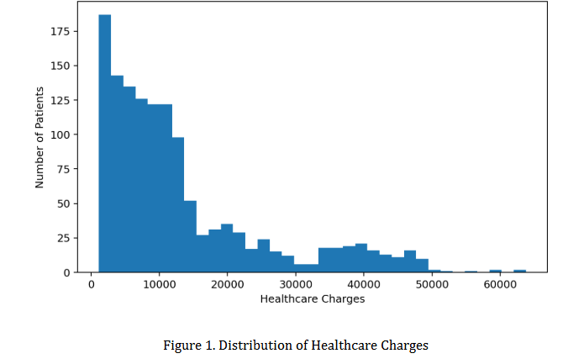
Figure 1. Distribution of Healthcare Charges
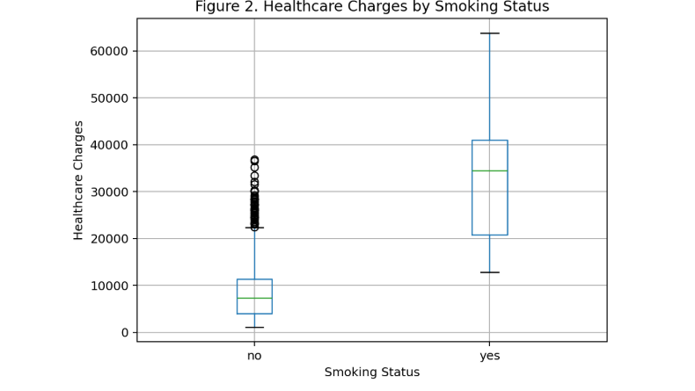
Figure 2. Healthcare Charges by Smoking Status
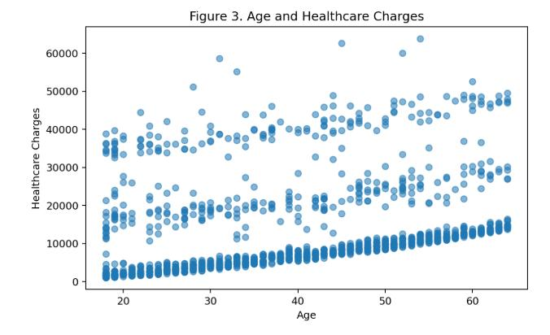
Figure 3. Age and Healthcare Charges
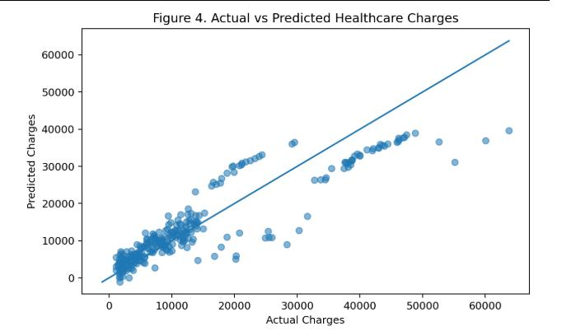
Figure 4. Actual vs Predicted Healthcare Charges

4.5 Data Analysis & Engineering Judgment
The model results indicate useful baseline predictive capability. The MAE of approximately $4,177 means that, on average, the absolute difference between predicted and actual charges on the test set is around $4,177. The RMSE of approximately $5,956 gives greater weight to larger errors and therefore indicates that some observations have substantially larger deviations. The results should be interpreted as performance on this dataset and split, not as a guarantee of performance on another population.
Smoking status is particularly important in the dataset. The average charge for observations labelled smoker = yes is approximately $32,050.23, compared with approximately $8,434.27 for non-smokers. This difference does not establish causality, but it demonstrates why smoking status is an important predictive feature in the dataset. Regional averages also vary: the southeast has the highest mean charge among the four regions at approximately $14,735.41, while southwest is approximately $12,346.94.

4.6 Comparison with Existing Solutions & Achievement of Objectives
Objective | Evidence | Achievement
Develop clean data workflow | Validation, duplicate removal and preprocessing pipeline | Fully Achieved
Explore demographic, lifestyle, BMI, regional and cost patterns | Statistical summaries and visualizations | Fully Achieved
Develop multiple linear regression model | 80:20 split, one-hot encoding and regression | Fully Achieved
Evaluate model | R², MAE, MSE, RMSE, residual and actual-vs-predicted analysis | Fully Achieved
Implement Streamlit application | Three-module local web interface | Fully Achieved
Provide interpretable outputs | Coefficients, charts and evaluation metrics | Fully Achieved

4.7 Strengths & Limitations
Strengths:
- End-to-end workflow from raw dataset to interactive application.
- Interpretable linear regression model with visible coefficients.
- Reproducible preprocessing and fixed train-test split.
- Multiple evaluation metrics and residual analysis.
- Clear limitation statement appropriate for a high-impact domain.
Limitations:
- The dataset is relatively small and contains limited predictors.
- The target represents insurance charges rather than a complete medical record.
- Linear regression may not capture all nonlinear relationships.
- Performance is reported for one held-out split and requires stronger validation before broader deployment.
- The application does not process identifiable patient records or connect to a live healthcare information system.

4.8 Project Planning, Roles & Budget
The source report does not provide a Gantt chart, detailed role allocation, or project budget. To preserve accuracy, these items are not invented in this reformatted report.
Student | Assigned Responsibility | Actual Contribution
Sania Herbert (192324062) | Not specified in source report | To be completed by team
Y. Anjani Priya (192324176) | Not specified in source report | To be completed by team
M. Apurva (192325138) | Not specified in source report | To be completed by team

Item | Estimated Cost | Actual Cost
Not specified in source report | — | —

CHAPTER 5
CONCLUSION, FUTURE WORK AND REFLECTION

5.1 Conclusion
This capstone project developed a Healthcare Cost Prediction and Analytics System that addresses the challenge of estimating healthcare charges from demographic, lifestyle, and regional variables. The solution combines data cleaning, exploratory analysis, multiple linear regression, model evaluation, and Streamlit-based local deployment. The dataset contained 1,338 observations; after removing one duplicate, 1,337 records were used. The model achieved an R² of approximately 0.807 with an MAE of approximately $4,177 and RMSE of approximately $5,956 on the held-out test set.
The main value of the project is not only the numerical prediction but also the integration of the prediction into an understandable application. Users can inspect the data, enter a hypothetical patient profile, receive a cost estimate, and review model performance. This creates a complete demonstration of the path from data to decision-support interface.
At the same time, the project recognizes that healthcare is a high-impact domain. The model should therefore be treated as a baseline analytical tool, not as a replacement for professional judgement or as an autonomous system for medical or insurance decisions.

5.2 Future Work
- Compare linear regression with Random Forest Regression, Gradient Boosting, XGBoost, or other nonlinear models.
- Use cross-validation to obtain a more robust estimate of generalization performance.
- Introduce hyperparameter optimization for nonlinear models.
- Add feature engineering, including interaction terms such as age-smoking and BMI-smoking interactions.
- Add validated variables such as income, healthcare utilization, medical history, plan type, and geographic cost indicators where legally and ethically available.
- Add privacy controls, model monitoring, periodic retraining, and stronger validation before any real-world deployment.
- Perform fairness and subgroup evaluation before using predictions for decisions affecting individuals.

5.3 Professional Learning & Individual Reflection

New Knowledge Acquired
- Understanding the complete data-science lifecycle from data cleaning through deployment.
- Application of statistics, exploratory data analysis, supervised learning, categorical encoding, regression and model evaluation.
- Understanding the distinction between association and causation in predictive modelling.
- Understanding software quality, transparency, interpretability, privacy and fairness considerations.

Engineering & Professional Skills Developed
- Python, Pandas, scikit-learn, Plotly, Streamlit, Joblib and modular application development.
- Pipeline construction and consistent preprocessing between training and prediction.
- Use of R², MAE, MSE and RMSE for regression evaluation.
- Systematic debugging of data, preprocessing, package/environment and application problems.
- Technical documentation and communication of model decisions and limitations.

Individual Reflection
The source report describes personal and professional growth at the project level but does not provide separate four-to-five-line reflections for each named student. Therefore, individual student reflections are intentionally left for the team to complete rather than assigning unsupported experiences to specific members.
Student | Individual Reflection
Sania Herbert (192324062) | To be completed by the student based on actual individual experience.
Y. Anjani Priya (192324176) | To be completed by the student based on actual individual experience.
M. Apurva (192325138) | To be completed by the student based on actual individual experience.

REFERENCES
1. Kaushik, K., Bhardwaj, A., Dwivedi, A. D., & Singh, R. (2022). Machine learning-based regression framework to predict health insurance premiums. International Journal of Environmental Research and Public Health, 19(13), 7898. https://doi.org/10.3390/ijerph19137898
2. Ul Hassan, M., et al. (2021). A computational intelligence approach for predicting medical insurance cost. Mathematical Problems in Engineering, 2021, 1162553. https://doi.org/10.1155/2021/1162553
3. Cenita, J. A. S., Asuncion, P. R. F., & Victoriano, J. M. (2023). Performance evaluation of regression models in predicting the cost of medical insurance. arXiv.
4. Sabarinath, U. S., & Mathew, A. (2024). Medical insurance cost prediction. Indian Journal of Data Communication and Networking. https://doi.org/10.54105/ijdcn.D5037.04040624
5. Sabarinath, U. S., & Mathew, A. (2024). Medical insurance cost prediction [Data set]. Zenodo.
6. Kaushik, K., Bhardwaj, A., Dwivedi, A. D., & Singh, R. (2022). Machine learning-based regression framework to predict health insurance premiums. PubMed. https://pubmed.ncbi.nlm.nih.gov/35805557/
7. Machine learning for an explainable cost prediction of medical insurance. (2024). Machine Learning with Applications, 15, 100516. https://doi.org/10.1016/j.mlwa.2023.100516
8. Estimation and prediction of hospitalization and medical care costs using regression in machine learning. (2022). BioMed Research International.
9. Bertsimas, D., et al. (2018). Supervised learning methods for predicting healthcare costs: Systematic literature review and empirical evaluation. Health Services Research.
10. Predictive interpretable analytics models for forecasting healthcare costs using open healthcare data. (2024). International Journal of Medical Informatics.

APPENDICES

Appendix A – Detailed Calculations
The model follows the ordinary least-squares linear regression form: ŷ = β₀ + β₁x₁ + β₂x₂ + … + βₚxₚ. Categorical variables are represented using one-hot encoded variables.
The fitted coefficients reported in the source report include approximately +248.21 for age, +318.70 for BMI, +533.01 for children, −101.54 for sex_male, +23,077.76 for smoker_yes, −391.76 for region_northwest, −838.92 for region_southeast, and −659.14 for region_southwest, relative to the selected reference categories.

Appendix B – Engineering Drawings / Schematics
Dataset → Validation/Cleaning → EDA → Encoding → Train/Test Split → Regression → Evaluation → Streamlit

Appendix C – Source Code / Code Repository Information
The source report describes a modular implementation consisting of data_preprocessing, model_training, prediction, and app.py. The documented application launch command is python -m streamlit run app.py. Complete source code is not reproduced here.

Appendix D – Data / Model Information
Core prediction inputs: age, sex, BMI, children, smoker, and region. Target variable: charges. The model is stored as a Joblib file for reuse.

Appendix E – Experimental / Raw Data
The supplied insurance dataset contains 1,338 original observations and seven variables. One duplicate was removed, resulting in 1,337 observations used for modelling. No missing values were reported.

Appendix F – Ethics / Institutional Approval
The source report does not provide a separate institutional approval record. It explicitly positions the application as an educational and analytical prototype and states that it does not process identifiable patient records.

Appendix G – Project Meeting / Progress Records
Not provided in the source report.

Appendix H – User / Industry Feedback
Not provided in the source report.

Appendix I – Publications / Patents / Competitions / Product Outcomes
Not provided in the source report.

Appendix J – Individual Contribution Evidence
The source report names three team members but does not include individual contribution evidence or percentage allocation. This section should be completed with actual evidence before final submission.

CAPSTONE PROJECT OUTCOME MAPPING SHEET
Outcome | Evidence | SO / Area | Location in This Report
Complex engineering problem formulation | Problem definition, need, objectives and scope | SO1 | Chapter 1, Chapter 2
Engineering design under constraints | Requirements, standards, design selection, trade-offs | SO2 | Chapter 3
Written/oral technical communication | Complete structured report and presentation-oriented outputs | SO3 | Whole report + Viva
Ethics and professional responsibility | Ethics, limitations, privacy and appropriate-use statements | SO4 | Chapter 3 (3.7)
Teamwork and leadership | Team member and contribution sections | SO5 | Chapter 4 (4.8)
Experimentation, analysis, engineering judgment | Testing, evaluation metrics, residual analysis and interpretation | SO6 | Chapter 4 (4.3–4.6)
Independent acquisition of new knowledge | Learning outcomes and technical skills | SO7 | Chapter 5 (5.3)
Standards | ISO/IEC 25010:2023 and NIST AI RMF principles | SO2 | Chapter 3 (3.2)
Sustainability and societal/environmental impact | Sustainability and appropriate-use considerations | SO2/SO4 | Chapter 3 (3.7)
Risk assessment and mitigation | Risk register and mitigations | SO2/SO4 | Chapter 3 (3.7)
Security considerations | Privacy and security considerations | Relevant SO | Chapter 3 (3.7)
Integrated/system-level engineering | Modular architecture and subsystem interfaces | SO1/SO2 | Chapter 3 (3.5)
Project planning and management | Planning/roles/budget section | SO5 | Chapter 4 (4.8)
Individual contribution | Contribution statement and reflection placeholders | SO1–SO7 | Contribution Statement + Chapter 4/5

